CLIENT | TP-OTC | PROJECT | SAKARYA GAS FIELD DEVELOPMENT PROJECT PHASE 3
JOB | 033781 | PURCHASE ORDER | 1534963 dtd. 21.10.2025
VENDOR / PLACE | Tenaris Confab / Brazil | VENDOR JOB NUMBER | TBA
SUB-VENDOR / PLACE | Av. Gastão Vidigal Neto, 475 – Pindamonhangaba – SP - Brasil | SUB-VENDOR JOB NUMBER | N/A Yet
TYPE OF MATERIAL | UOE SAWL PIPE OD 609.6mm X WT 32.2mm DNV 450 FSDU
RULES AND CODES | DNV-ST-F101
SPECIFICATIONS AND DRAWINGS | SC26-3-WOR-GEP-FL-SPC- 001018_R02

IDS  Inspection Data sheet | X | Not To Be Issued |  | To Be Issued |  | Issued
Pre inspection meeting (PIM) | X | Already Held |  | To Be Planned |  | Not To Be Held
Type of inspection |  | Pre Inspection Visit | X | Construction Inspection
Partial
(of whole PO)
 | X | Intermediate Test | X | Acceptance Test
Balance
(of whole PO)
Last Inspection | X | Yes |  | No

MATERIAL / DESCRIPTION / REF. DOCUMENTS | TYPE OF TEST | W (1) | RESULT | ISSUED DOCUMENTS  (2)
UOE SAWL PIPE OD 609.6mm X WT 32.2mm DNV 450 FSDU | MPQT/WPQT & Early Pipes | N/A | Approved with comments | N/A

NOTES: During these weekly activities there were 3 points noted at “Areas of concerns” Steel Damages

ATTENDEES:

Organization | NAME OF ATTENDEES
IQS | Pedro Eugenio
IQS | Elbert Morais
IQS | Kayan Silva
IQS | Robson Honorato
IQS | Jose Antônio
IQS | Mateus Larangeira
IQS | João Paulo
TP OTC | Jose Patricio Monteiro
RINA | Aruã Pelissario
RINA | Nilson Coutinho
Tenaris Confab | Bruna Pereira
Tenaris Confab | Felipe Cunha
Tenaris Confab | Teresa Bras
Tenaris Confab | Saulo Silva
SCOPE OF INSPECTION:
description | result
Pipe Mill rWPQT and Mass Production | Approved with Comments

DOCUMENT USED:
document used | Doc. number | rev. | issue date
MPS - Manufacturing Procedure Specification- Pipe Mill (SAIPEM) | SC26-3-CNF-GEP-MN-MPS-707004 | 01 | 12/12/2025
ITP - Inspection and Tests Plan (Pipe Mill) | SC26-3-CNF-GEP-MN-ITP-707005 | 01 | 18/12/2025
Line pipe Specification | SC26-3-WOR-GEP-FL-SPC-001018 | 02 | 10/03/2025
NDT | SC26-3-CNF-GEP-ND-PRO-707008 | 00 | 14/10/2025
Dimensional and Visual Procedure | SC26-3-CNF-GEP-ND-PRO-707009 | 00 | 29/10/2025
Material Traceability and Marking Procedure | SC26-3-CNF-GEP-QA-PRO-707013 | 00 | 29/10/2025
pWPS and Weld Repair WPS | SC26-3-CNF-GEP-WE-PRO-707006 | 01 | 19/12/2025
Line pipe Specification | SC26-3-WOR-GEP-FL-SPC-001018 | 02 | 10/03/2025

DETAILS OF INSPECTION AND TEST INSTRUMENTS USED:
equipment name | manufacturer | S/N | next CALIBRATION
All the Instruments and equipments used during this weekly qualification/production were noted with valid calibration date.

ATTACHMENTS:
DESCRIPTION | TYPe | PAGEs
Sakarya Inspection Overall Status (Updated as of 06.20.2026) | Excel Table | https://fanatics-hue.github.io/sakarya-dashboard/

DETAILS AND RESULTS OF INSPECTION:
M A T E R I A L I N S P E C T E D |  | Q U A N T I T Y (PCS)
ITEM NO | BRIEF DESCRIPTION | TOTAL ORDER | PRESENTED | ACCEPTED | Previously accepted
1 | DNV SAWL 450 SFDU - External 3LPP coating (+ rough coat)- Pipes for Onshore Route | 1525 | 0 | 0 | 0
2 | DNV SAWL 450 SFDU - External 3LPP coating (+ rough coat) - Pipes for Onshore FJC PQT + PPT | 0 | 0 | 0 | 0
3 | DNV SAWL 450 SFDU - External 3LPP coating + rough coat - Pipes for Route R6 + Wet Buckle Contingency SEE GENERAL REMARKS FOR DETAILS RELATED TO REQUIRED DELIVERY DATE | 186562.4 | 0 | 0 | 0
4 | DNV SAWL 450 SFDU - External 3LPP coating + rough coat - Pipes for Installation A/R tail / Dummy string | 0 | 0 | 0 | 0
5 | DNV SAWL 450 SFDU - External 3LPP coating + rough coat - Pipes for Equip. Calib + Tests (Frict + Fat) | 12.2 | 0 | 0 | 0
6 | DNV SAWL 450 SFDU - External 3LPP coating + rough coat with 50 mm CWC | 0 | 0 | 0 | 0
7 | DNV SAWL 450 SFDU - External 3LPP coating + rough coat with 120 mm CWC | 0 | 0 | 0 | 0
8 | DNV SAWL 450 SFDU - Bare - Pipes ONSHORE DIV SPOOL | 12.2 | 12,43 M | 12,43 M | 0
9 | DNV SAWL 450 SFDU - Bare - Pipes for Installation and Precom Heads | 48.8 | 49,33 M | 49,33 M | 0
10 | DNV SAWL 450 SFDU - Bare - Pipes for Contractor Offshore (PTC) WPQT – For Welding Laboratory | 122 | 124,07 M | 124,07 M | 0
11 | DNV SAWL 450 SFDU - Bare - Pipes for Contractor Onshore WPQT – For Welding Laboratory | 48.8 | 49,16 M | 49,16 M | 0
12 | DNV SAWL 450 SFDU - Bare - Pipes for Contractor WPQT – For Welding Vessel (Lay Vessel) | 292.8 | 0 | 0 | 0
13 | DNV SAWL 450 SFDU - External 3LPP coating + rough coat - Pipes for Offshore FJC PQT + PPT - SLOTTED (9-OFF SLOTS, PTC) NOTE: slots on 3LPP shall be prepared to simulate field joint coating, each slot has width 340 -0/+40mm (double cutback), FBE tail 3-10m | 109.8 | 0 | 0 | 0
14 | DNV SAWL 450 SFDU - External 3LPP coating + rough coat with 50 mm CWC - Pipes for Offshore FJC PQT + PPT - SLOTTED (7-OFF SLOTS, PTC) NOTE: slots on CWC shall be prepared to simulate field joint coating, each slot has width 740 -0/+40mm (double cutback), | 0 | 0 | 0 | 0
15 | DNV SAWL 450 SFDU - External 3LPP coating + rough coat with 120 mm CWC - Pipes for Offshore FJC PQT + PPT - SLOTTED (7-OFF SLOTS, PTC) NOTE: slots on CWC shall be prepared to simulate field joint coating, each slot has width 740 -0/+40mm (double cutback), | 0 | 0 | 0 | 0
16 | DNV SAWL 450 SFDU - Bare - Pipes for Offshore BA FJC PQT + PPT - SLOTTED (9-OFF SLOTS, PTC) NOTE: to be supplied bare | 0 | 0 | 0 | 0
17 | ON 50MM CWC (5pcs) | 0 | 0 | 0 | 0
18 | CWC (11PCS) | 1 | 0 | 0 | 0
19 | (675 pcs) | 1 | 0 | 0 | 0
20 | TBD | 1 | 0 | 0 | 0
21 | DNV SAWL 450 SFDU - EXTERNAL 3LPP COATING + ROUGH COAT - Pipes for Onshore FJC - SLOTTED (3LPP, 9-off SLOTS, to Subcontractor onshore) NOTE: SLOTS ON 3LPP SHALL BE PREPARED TO SIMULATE FIELD JOINT COATING, EACH SLOT HAS WIDTH 340 -0/+40MM (DOUBLE CUTBACK) | 36.6 | 0 | 0 | 0
22 | DNV SAWL 450 SFDU - BARE Pipes for Onshore (future use: FJC - SLOTTED FSPP, 9-off SLOTS, to Subcontractor onshore) NOTE: TO BE SUPPLIED BARE | 36.6 | 36,87 M | 36,87 M | 0
23 | DNV SAWL 450 SFDU - External 3LPP coating + rough coat with 70 mm CWC | 1976.4 | 0 | 0 | 0
24 | DNV SAWL 450 SFDU - Bare Pipes for MIJ | 12.2 | 11,83 M | 11,83 M | 0
25 | DNV SAWL 450 SFDU - Bare Pipes for PLET Piping (no Bends, HOP solution) | 12.2 | 12,34 M | 12,34 M | 0
26 | DNV SAWL 450 SFDU - External 3LPP coating + rough coat Pipes for compatibility test with FJC SLOTTED (9 -OFF SLOTS, PTC) NOTE: SLOTS ON 3LPP SHALL BE PREPARED TO SIMULATE FIELD JOINT COATING, EACH SLOT HAS WIDTH 340 -0/+40MM (DOUBLE CUTBACK), FBE TAIL 3-1 | 12.2 | 0 | 0 | 0
27 | DNV SAWL 450 SFDU - Spare - EXTERNAL 3LPP COATING + ROUGH COAT - Pipes for Offshore FJC - NOT SLOTTED, PTC) | 48.8 | 0 | 0 | 0
28 | DNV SAWL 450 SFDU - Spare - EXTERNAL 3LPP COATING + ROUGH COAT - Pipes for Offshore FJC + CWC 70mm - SLOTTED (7-OFF SLOTS, PTC) - ONLY ONE CWCT NOTE: SLOTS ON CWC SHALL BE PREPARED TO SIMULATE FIELD JOINT COATING, EACH SLOT HAS WIDTH 740 -0/+40MM (DOUBLE | 48.8 | 0 | 0 | 0
29 | DNV SAWL 450 SFDU - Spare - Bare PLET Piping for PLET Yard - Welding qualification and welder qualifications | 85.4 | 86,51 M | 86,51 M | 0
30 | TBD | 12.2 | 12,43 M | 12,43 M | 0
31 | TBD | 12.2 | 12,30 M | 12,30 M | 0
32 | TBD | 12.2 | 12,23 M | 12,23 M | 0
33 | TBD | 24.4 | 24,48 M | 24,48 M | 0
34 | DAP DELIVERY | 1 | 0 | 0 | 0
35 | PLANT MODIFICATION | 1 | 0 | 0 | 0

NON-CONFORMANCES
NCR | DESCRIPTION | DATE RAISED | DATE CLOSED
01 | MPQT Burn Through | 02/12/2026 | 03/26/2026
02 | MPQT and Early Pipes Bevel Profile Damage | 02/14/2026 | 04/21/2026
03 | CVN and Tensile MPQT Failure | 03/09/2026 | 04/14/2026
04 | CVN Early Pipe Failure (Heat Frequency) | 04/15/2026 | Open
05 | 3LPP PQT Pipe damaged at Cutback Brush | 04/28/2026 | 05/19/2026
06 | 3LPP Early Batch Elongation Rejection | 04/29/2026 | Open
07 | Slotted Pipe N° 26.4.2195 (9 Slots) | 05/18/2026 | 05/19/2026
08 | Tensile Strength 60°C (both extruded and from pipe) | 05/26/2026 | Open
09 | Tack Weld Parameters out of the Qualified | 06/11/2026 | Open
10 | NDT Tenaris Inspector (ASNT x ISO) | 06/15/2026 | Open
11 | Mechanical Marking at Pipe ID | 06/15/2026 | Open
12 | Mechanical Cold Expansion Rate | 06/15/2026 | Open

SAWL UOE Pipe Mill MPQT/WPQT and Mass Production
MPQT/WPQT started together with the Early Pipes Production on Feb. 09th 2026, and the progress is still ongoing with the Repair Qualifications:
The Pipe Mill Mass Production was started on Jun. 02nd 2026, and still ongoing, please, see below on Mass Production Section

MPQT/WPQT PIPES PROCESS
Please, see in the previous IR the 8 Plates/Pipes Traceability Numbers for MPQT/WPT, with all the parameters and results performed during the Qualification Process.

rWPQT REPAIR

STOP/START - rWPQT
Tenatis have performed a forced STOP/START on the Pipe N° 26.4.2128 to simulate and qualify this Repair as MPS SC26-3-CNF-GEP-MN-MPS-707004_R01_2 Section 6.1.7 (WPQT)
Internal Forced Weld Machine Stop at 1760x650
External Forced Weld Machine Stop at 11480x650

OD SIMULATED REPAIR - rWPQT
The Pipe N° 26.4.2128 with ID and OD Stop/Start Welding Repair Qualification and to perform the SAWL Outside Weld Deep repair (Qualification > 0.7 x WT) WPS Number EPR-F4-0266 and the Shallow repair - cap (Qualification up to 8 mm depth) WPS Number EPR-F4-0265, 6 Deep Cavities plus 3 with Shallow Cavities. Due to the Rejection of the 1st Deep Simulated Deep Plate, Tenaris has opened two more Deep Cavity, one to replace the 1st Rejected, and another one for Back-up, also one more for Shallow as a Back-up was open.
The SMAW welding process was started on Apr. 8th, 2026, and was finalized on Apr. 23rd, 2026.

During Jun 08th, 2026 and these weekly activities, some Stop/Start and the Welding Repair Qualification some OD/ID Stop/Start Repair Test were performed, please see below:

- Macrographic Test – Performed and approved
- Guided Side Bend Tests – Performed and approved
- CVN Test – Performed and approved with the below point Noted: ID Stop/Start middle weld results were in a Border Line with the following Results:
Specimen1 = 46J; Specimen2 = 48J; Specimen3 = 47J; Average = 47J

Please see some pictures at the PHOTO section below:

ID SIMULATED REPAIR – rWPQT
On Apr. 25th, 2026; at the Pipe N° 26.4.2205 to perform the Deep repair (Qualification > 0.7 x WT) WPS Number EPR-F4-0266 and the Shallow repair - cap (Qualification up to 8 mm depth) WPS Number EPR-F4-0265.
For the Shallow and Deep ID Repair Qualification, 12 Cavities were opened (8 for Deep and 4 for Shallow rWPQT).
The ID SMAW welding process started on May 4th, 2026; and was finalized May 12th, 2026, however Tenaris have taken the option to open one more Deep Simulate Repair Cavity please see below the parameters, witnessed during last weekly activities for the lasts Plate N° 8:

During these weekly activities there were no activities performed on the ID Simulated Repair Qualification.

PIPE MILL MASS PRODUCTION
The below quantities out of the 8 MPQT/WPQT Pipes are Early Pipes and Mass Production
The Pipe Mill Mass Production was Notify to be started on May 27th, 2026; than postponed to May 29th, 2026, and then it was really started on Jun. 02nd 2026, and still ongoing, please, see below:

Pipe Mill Production Sequence
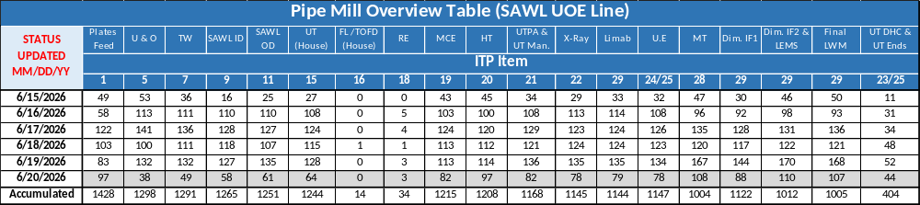
U & O- U-Forming and O-Forming; TW- Tack Welding; SAWL ID- Inside Welding; SAWL OD- Outside Welding; UT (House)- Process Control UT of Weld Seam; FL- Fluoroscopic Inspection TOFD – UT of Weld Seam; RE- Manual Weld Repair of the Weld Seam (if applicable); MCE- Mechanical Cold Expansion; HT- Hydrostatic Testing; UTPA- Automatic phased array UT; UT Man.- Manual UT to check indications detect in UTPA; UT Ends-Ultrasonic Inspection of Pipe Ends plus UT DHC-Manual UT for DHC Detection; MT-Magnetic Particle Inspection; Dim. IF1-Final Dimensional Table 1; Dim. IF2-Final Dimensional Table 2, Final LWM- length measurement, Weighting, marking, LEMS- Laser Dimensional.
For Repair and Rejection Pipes Traceability, please, see “Sakarya Inspection Overall Status as of 06.20.2026”
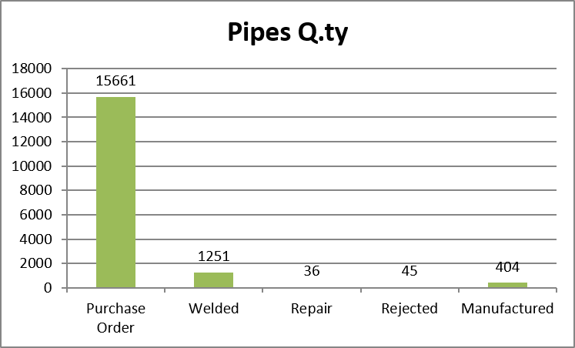

Plate Receiving and Feeding and TAB Welding:
A visual inspection over the plate (Pipe ID) was conducted, at the same station, the plate gets a pipe number. The TAB plates with the same project material are welded by GMAW and are within more than 200mm of length

Cutting and Milling of Plate Edge:
A spot plate of each shift had all the dimensions taken during the dimensional inspection, all measurements inspected were inside the applicable Longitudinal Bevel Dimensional Tolerance as WPS-EPS-F4-3973 Rev. 02

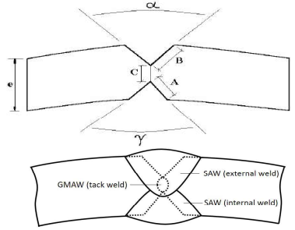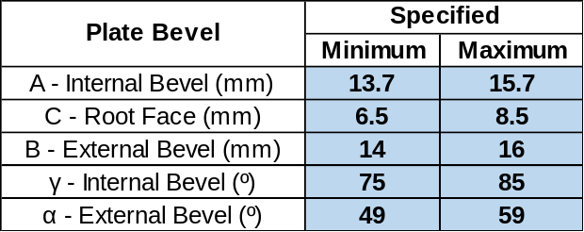

Pre-Forming of Edges:
Were realized with no problem noted, the edges shape was spot verified with a calibrated caliper (go/no go and instruments).

U and O Forming
U and O forming performed with no problem noted, for the final Dimensional Inspection, this item is realized only after the Mechanical Expansion station. Were realized perimeter, shaped by a calibrated caliper and gap between the borders, these were monitored only.

Chamfer Cleaning, Washing and Drying of pipe:
The plates chamfers were cleaned with degreasing compound applied by spray gun and, were washed with soap and by a high-pressure water to eliminate the oil from the forming process. Pipes were washed inside and outside, water jet and dried with blown hot air (flames).

Tack Welding and Radial Off set:
The Pipe was welded by the GMAW process controlled to ensure alignment of plate edges, all the parameters and the consumables used were monitored and are inside the specified on the above, the consumables certificates were requested to Tenaris. The Radial Offset found during the measurements were between the minimum of 0.1mm to the maximum of 1.1mm (specified maximum with 2.0mm).

Please, see NOTE and NCR-009 for the Tack Welding Station

SAWL Inside Welding:
Pipe positioned with the weld at 06:00hr, four wires were used as per WPS. All Pipes welded, have a system record, and during the monitoring all parameters, consumables and welder operators’ code were found as per qualified range and specification, please, see below the Operators welding code:
SEM; UEN; UGI; UGY; UHC; UAN; UFX; UGM; UCA and UGC;

SAWL inspection of inside weld seam:
Performed 100% of the Pipes as per new ITP revision. The Pipes were visually inspected, and no defect was noted in this station during these weekly activities.

SAWL Outside Welding
Pipe positioned with the weld at 12:00hr, four wires used as per pWPS. All Pipes welded, have a system record, and during the monitoring all parameters, consumables and welder operators’ code were found as per qualified range and specification, please, see below the Operators welding code:
UGB; UDR; UFO; UCM; UFY and UHA

Removing TAB:
The TABs have been removed by plasma cut method.

Inspection of Outside Weld Seam
Performed 100% of the Pipes as per new ITP revision. The Pipes were visually inspected, and no defect was noted in this station during these weekly activities.

Pipe Straightening (if applicable)
During this Week 25, the Straightness’ re-work was started and still ongoing

NDT AUT and TOFD UT - in house test
Activities |  | Verifications | Remarks
Ultrasonic Inspection of Weld Seam | Automatic UT  (In House) | T. Inspector: Luiz Fernando Cesário and Anderson Geraldo | Standard Pipe F-558691
Ultrasonic Inspection of Weld Seam | Automatic UT  (In House) | Cal time: Start of shift | Standard Pipe F-558691
Ultrasonic Inspection of Weld Seam | Automatic UT  (In House) | Check Time: 4 in 4 hours | Standard Pipe F-558691
Ultrasonic Inspection of Weld Seam | TOFD UT  (In House) | T. Inspector: Fernando Dalilo and Diego Pereira | Standard Pipe F-558691
Ultrasonic Inspection of Weld Seam | TOFD UT  (In House) | Cal time: Start of shift | Standard Pipe F-558691
Ultrasonic Inspection of Weld Seam | TOFD UT  (In House) | Check Time: 4 in 4 hours | Standard Pipe F-558691

Outside Grinding of the Weld Reinforcement
The External welding reinforcement were grinded in this station, however the grinded weld bead length and high will be measured with the ITP item 29 and 30 (Dimensional Inspection).

Manual Welding Repair
Not applicable during these visits. Please, see on the “Sakarya Inspection Overall Status (Updated as of 06.20.2026)” sub-table Repair, with the pipes on hold due a repair detected during this first cycle.
Process under qualification as per SC26-3-CNF-GEP-WE-PRO-707006_R01_2.

Mechanical Cold Expansion
Expansion Rate witnessed during this weekly Mass Production were from 0,84% to 1,05% (Qualified expansion Rate is from 0,75% to 1,15%)
Hydrostatic Testing
Press witnessed during this weekly Mass Production were from: Minimum Pressure required is 6760 PSI for 10 seconds. Minimum Pressure = 6769 PSI; Maximum Pressure = 6790 PSI

NDT Inspection

Activities |  | Verifications | Remarks
Ultrasonic Inspection of Weld Seam | Automatic UT | T. Inspector: Wanderson Matos; Antonio Oliveira | N/A
Ultrasonic Inspection of Weld Seam | Automatic UT | Cal time: beginning of shift and check every 4 hours | N/A
Ultrasonic Inspection of Weld Seam | Automatic UT | Standard Pipe: F-558150 | N/A
Ultrasonic Inspection of Weld Seam | Manual UT | T. Inspector: Diogo Teixeira; Diogo Mathis; Valmir Prado; Josiney Pacheco; André Rangel | N/A
Ultrasonic Inspection of Weld Seam | Manual UT | Cal time: beginning of shift and check every 4 hours | N/A
Ultrasonic Inspection of Weld Seam | Manual UT | Standard Pipe:560560 | N/A
X-Ray Inspection of Weld | All Pipes Ends (300mm) & Repaired Area | T. Inspector: Roni Peterson; Josiney Pacheco; Rauber Batista and Diogo Rodrigues | N/A
X-Ray Inspection of Weld | All Pipes Ends (300mm) & Repaired Area | Sensibility: IQI W12 (Specified W11) | N/A
X-Ray Inspection of Weld | All Pipes Ends (300mm) & Repaired Area | Duplex: D9 (Specified from 1 to 12) Compensation rule has been applied | N/A
Ultrasonic Inspection of Pipe Ends | 200mm of Full Circumference (Angle Probe) | T. Inspector: | This Inspection has been performed together with the UT DHC, please see below
Ultrasonic Inspection of Pipe Ends | 200mm of Full Circumference (Angle Probe) | Cal time: beginning of shift and check every 4 hours
Ultrasonic Inspection of Pipe Ends | 200mm of Full Circumference (Angle Probe) | Standard Pipe:
Ultrasonic Inspection of Pipe Ends | 200mm of Full Circumference (Straight Probe - End Cut Only) | T. Inspector: Luiz Marcelo; Jean Carlos | N/A
Ultrasonic Inspection of Pipe Ends | 200mm of Full Circumference (Straight Probe - End Cut Only) | Cal time: beginning of shift and check every 4 hours | N/A
Ultrasonic Inspection of Pipe Ends | 200mm of Full Circumference (Straight Probe - End Cut Only) | Standard Pipe: 560239 | N/A
Magnetic Particle Inspection | MPI at Pipe Bevel | T. Inspector: Maurício de Jesus, Euclides de Oliveira, Sergion Silva and André Luiz | Black light – Min. 1000 µw/cm²; White light – Max. 10Lux; Piece Temperature – OK; Bath Temperature – OK; Efficiency examination and contaminant analysis – Ok; Contaminant Analysis – OK
Magnetic Particle Inspection | MPI at Pipe Bevel | Cal time: beginning of shift and check every 4 hours
Magnetic Particle Inspection | MPI at Pipe Bevel | Setting Volume / Sensitivity: 0,15ml / Ok
Magnetic Particle Inspection | MPI at Int. & Ext. Welding  (200mm Pipe Ends). | T. Inspector: Maurício de Jesus, Euclides de Oliveira, Sergion Silva and André Luiz
Magnetic Particle Inspection | MPI at Int. & Ext. Welding  (200mm Pipe Ends). | Cal time: beginning of shift and check every 4 hours
Magnetic Particle Inspection | MPI at Int. & Ext. Welding  (200mm Pipe Ends). | Setting Volume / Sensitivity: 0,15ml / Ok
Magnetic Particle Inspection | MPI Ext. Welding  (Full Pipe Length). | T. Inspector: Maurício de Jesus, Euclides de Oliveira, Sergion Silva and André Luiz | All the grinded areas have been inspected at this station
Magnetic Particle Inspection | MPI Ext. Welding  (Full Pipe Length). | Cal time: beginning of shift and check every 4 hours | All the grinded areas have been inspected at this station
Magnetic Particle Inspection | MPI Ext. Welding  (Full Pipe Length). | Setting Volume / Sensitivity: 2,0ml / Ok | All the grinded areas have been inspected at this station
Magnetic Particle Inspection | MPI Repair Welding  (Dry Method). | T. Inspector: N/A | Repair To be Qualified
Magnetic Particle Inspection | MPI Repair Welding  (Dry Method). | Cal time: N/A | Repair To be Qualified
Magnetic Particle Inspection | MPI Repair Welding  (Dry Method). | Check Time: N/A | Repair To be Qualified

Gas Cutting of Test Samples and Defects
Have been started during these weekly activities without any deviation noted.

Visual and Dimensional Inspection
During this first week of LEMS operation, a lot of OoR was found outside from the specification, please, see Remarks on “Areas of Concerns” section LEMS
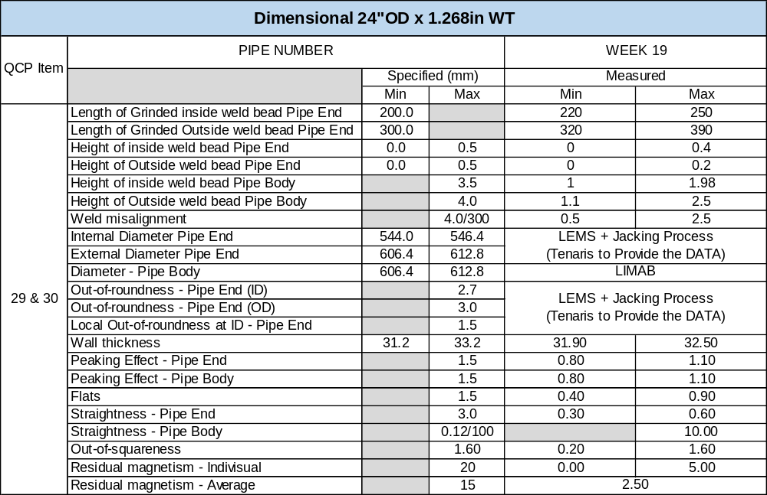

UT for DHC Detection (Offline Inspection)
Was started the UT DHC Inspection with a Phased Array Method, and Manual UT for confirmation, please see below the Tenaris Inspectors names:
Yan Vitor; Joel Cardoso; Lucas Antonio; Alselmo Miron; André Luis; Gustavo de Lima; Moacir Antonio; Andre Fonseca; Marcelo Penha; André Guimarães; Lucas Carvalho and Diogo Eduardo.

LABORATORY TEST
For the Tests Results please see a pdf file attached in the “Sakarya Inspection Overall Status as of 06.20.2026” Tables. Inside the table there is a PDF file with all Labs Tests results

Color legend for each test indicates in the MPQT-WPQT-Mass Production sub-file:

Green – Tests Performed and Approved.
Yellow – Test Performed with a Border Line Result.
Red – Test Performed and Rejected as per Specification.
Blue – Long Duration Tests Started.
Gey – Test to Be Performed.

MPQT/WPQT (AS FABRICATED)
For the MPQT/WPQT Pipes AF 26.4.2096; 2097; 2098 and 2240; MPQT As Fabricated Concluded.
WPQT missing the Repair Qualification SMAW to be concluded

MPQT (AS COATED)
For the MPQT Pipes AC 26.4.2099; 2100; 2101 and 2243; MPQT As Fabricated Concluded.

OD SIMULATED REPAIR plus ID and OD Stop/Start Welding Repair – rWPQT
Ongoing, please see Laboratory Tests performed during this week, on the attached Table, no failure was witnessed.

MASS PRODUCTION
Mass Production Laboratory Tests have started during last weekly activities, please see some outpoints of the approved ones performed:

CTOD: Requested by CPY to be performed in the 1st campaign was finalized, please see below the results
Sample 1 = 1.09mm; Sample 2 = 0.92mm; Sample 3 = 0.62mm

CVN Test: During today the CVN test was re-started, there were not a complete heat set tested; however, the below ones were REJECTED at the Fusion Line (OD and Root):
Pipe Number 26.4.7858; Heat Number 801219 – Results = Spec. 1=36; Spec. 2= 310; Spec. 3 = 311J (Root FL)
Pipe Number 26.4.7816; Heat Number 975002 – Results = Spec. 1=29; Spec. 2= 295; Spec. 3 = 251J (ID FL)
Pipe Number 26.4.7974; Heat Number 780993 – Results = Spec. 1=37; Spec. 2= 32; Spec. 3 = 298J (OD FL)
Pipe Number 26.4.8032; Heat Number 780995 – Results = Spec. 1=48; Spec. 2= 34; Spec. 3 = 35J (OD FL)
Pipe Number 26.4.7804; Heat Number 974992 – Results = Spec. 1=33; Spec. 2= 62; Spec. 3 = 82J (OD FL)
Pipe Number 26.4.7804; Heat Number 974992 – Results = Spec. 1=320; Spec. 2= 20; Spec. 3 = 309J (Root FL)
Pipe Number 26.4.7998; Heat Number 780992 – Results = Spec. 1=37; Spec. 2= 341; Spec. 3 = 328J (Root FL)
Pipe Number 26.4.8053; Heat Number 780991 – Results = Spec. 1=37; Spec. 2= 291; Spec. 3 = 244J (Root FL)
Pipe Number 26.4.8053; Heat Number 780991 – Results = Spec. 1=34; Spec. 2= 46; Spec. 3 = 255J (OD FL)
Pipe Number 26.4.7990; Heat Number 780992 – Results = Spec. 1=36; Spec. 2= 46; Spec. 3 = 284J (ID FL)
Pipe Number 26.4.8136; Heat Number 800959 – Results = Spec. 1=255; Spec. 2= 267; Spec. 3 = 31J (OD FL)
Pipe Number 26.4.8216; Heat Number 801174 – Results = Spec. 1=259; Spec. 2= 302; Spec. 3 = 24J (OD FL)
Pipe Number 26.4.8186; Heat Number 801174 – Results = Spec. 1=273; Spec. 2= 58; Spec. 3 = 33J (ID FL)
Pipe Number 26.4.7920; Heat Number 800943 – Results = Spec. 1=32; Spec. 2= 294; Spec. 3 = 279J (ID FL)

Base Metal Longitudinal Tensile Test: 10 heats were tested and the below one was REJECTED:
Pipe Number 26.4.7993; Heat Number 780992 with RT0.5/Rm = 0,94

Please see some pictures on the PHOTO section below.

Areas of Concern:

Pipe Mill Mass Production

Pipe/Plate Steel Damage
During a Visual and Dimensional Inspection at the Pipe Mill, at Plate entrance and Dimensional Station 1, were noted a deep Internal surface on the base metal, around on the middle pipe length, with a position on other weld bead side, from 180° from the weld seam with a depth found so far from 3 to 5mm. It was identified that was caused by the “U” Press, for a foreign material melted in the press surface.
Two different kinds of Mechanical Damage were noted, some with a bolt aspect, and another one as Stamp Damage at the ID Pipe Surface. Please see below the quantities of each defect:

Summary until today’s visit

“U” Press Mark - 63 Pipes Identified and 18 Rejected already

Bolt Mark: 5 Pipes identified 1 Pipe Rejected and 18 Plates Identified

Stamp Damage: 46 Pipes identified 3 Rejected and 43 on the line without any rework, plus 8 Plates measured and rejected, the rejected plates will be used by Tenaris to become a TAB.

An email was sent to Tenaris, requesting a traceability control for the above Damages, and besides it, this TPI team has create one excel Table, with our data to control the above situations.

Laboratory
Please see above the CVN and Base Metal Longitudinal Tensile Test performed during these weekly activities with Failure Results

PHOTOGRAPHS

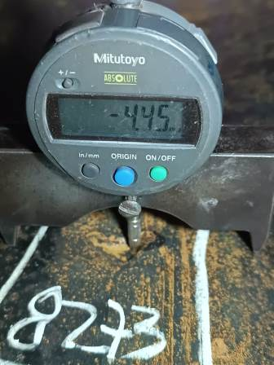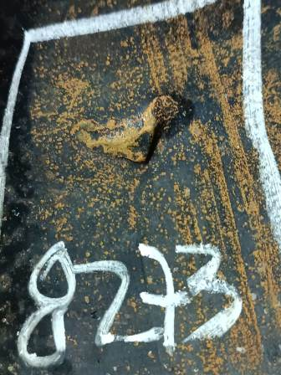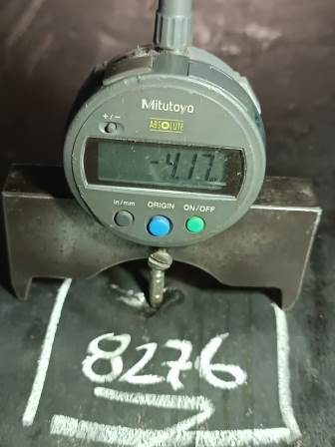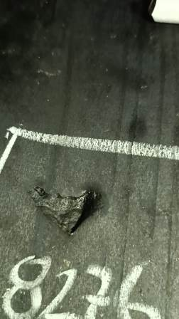
Mechanical Damage

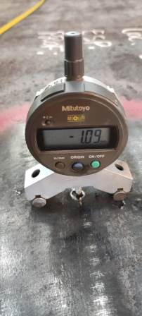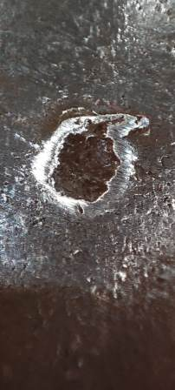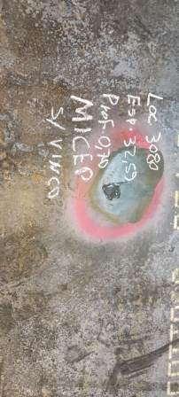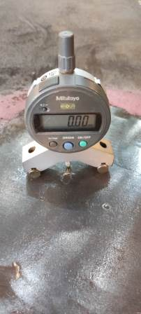
Pipe Mill Activities – Stamp Damage

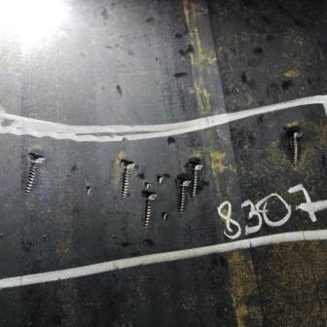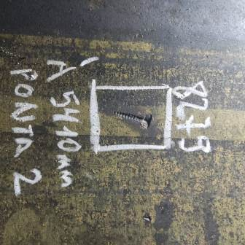
Bolt Mechanical Damage at ID Pipe Surface

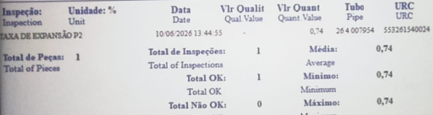
Mechanical Cold Expansion

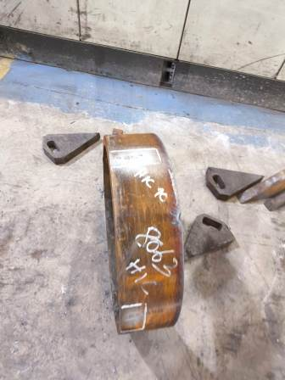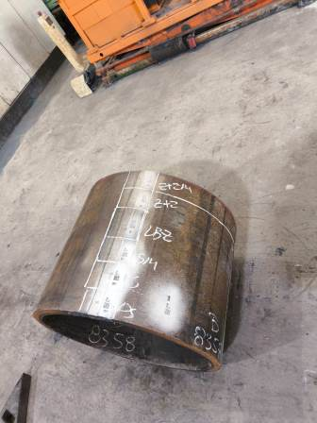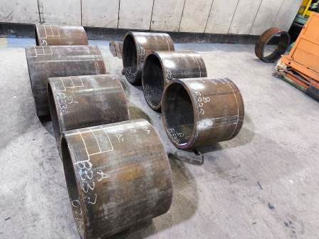
Pipe Mill Sample Removal

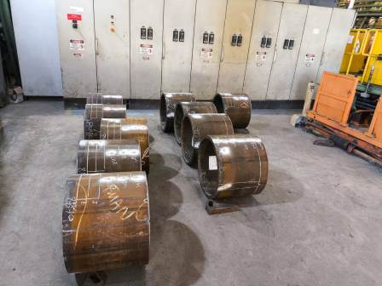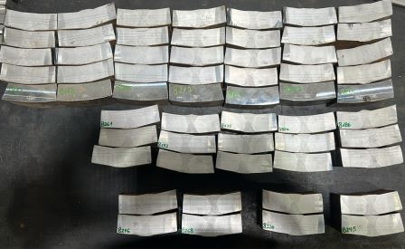

Laboratory rWPS and Mass Production Tests

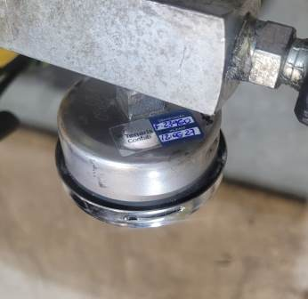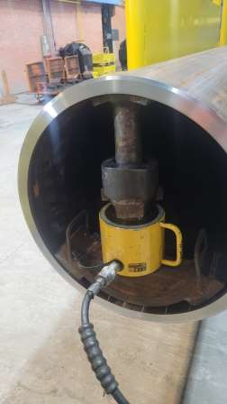
Jacking Process at the OoR Rejected Pipes

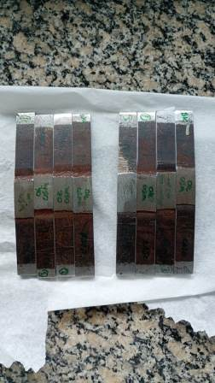
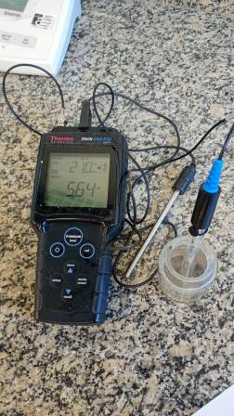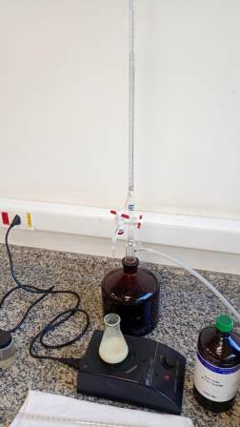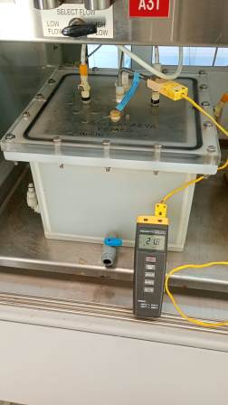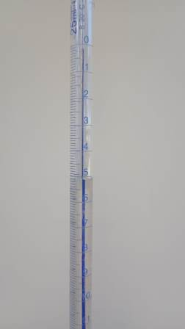
OD Shallow and Deep Repair Qualification SSC Tests started

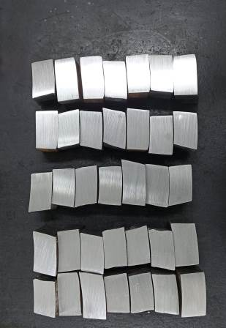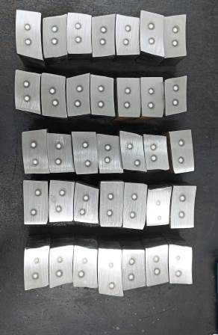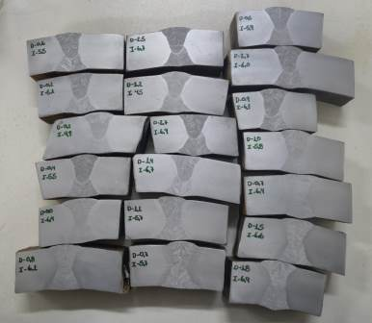

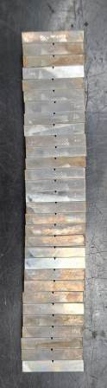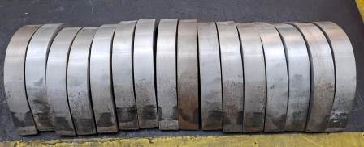

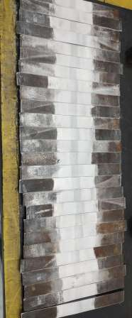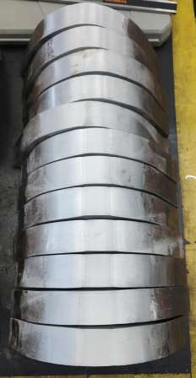

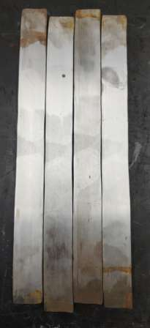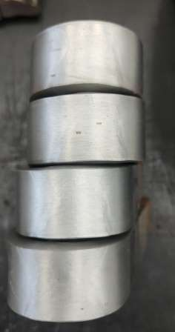

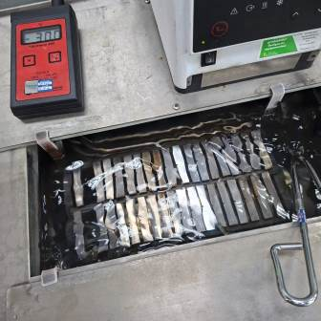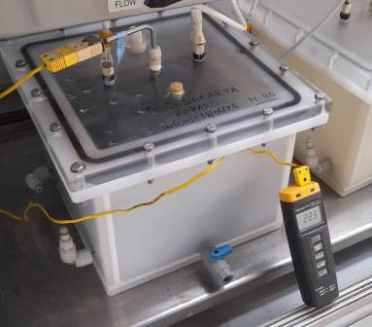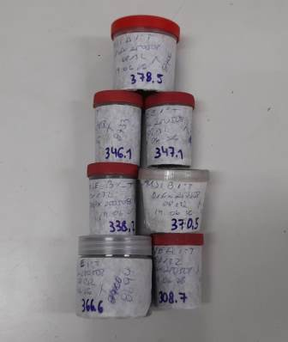

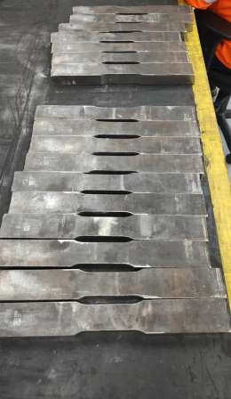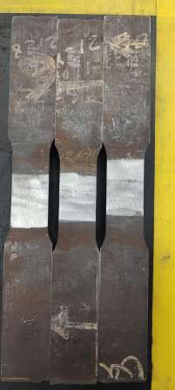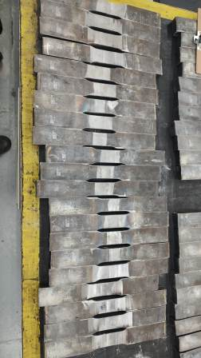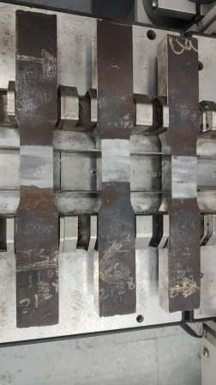

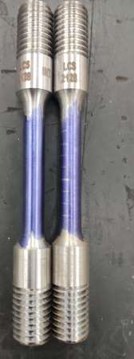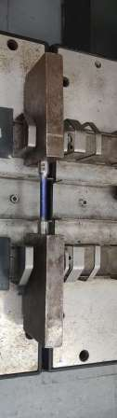

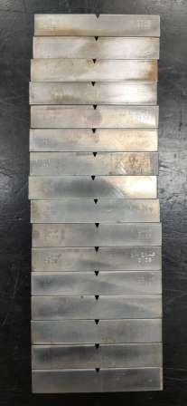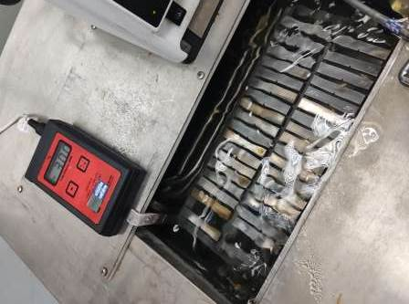
Laboratory Tests

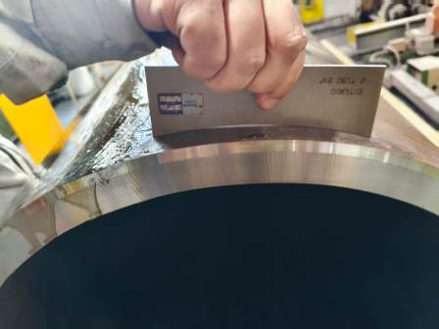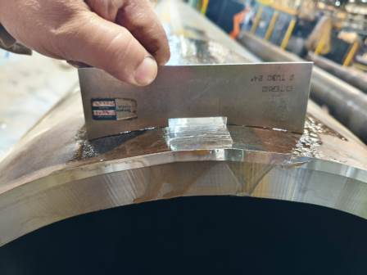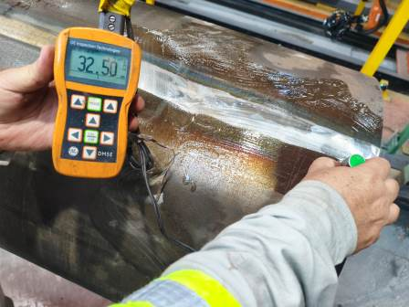

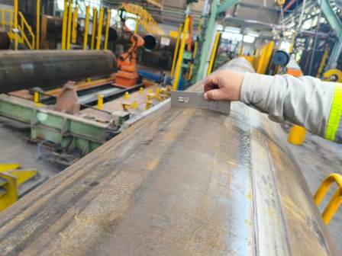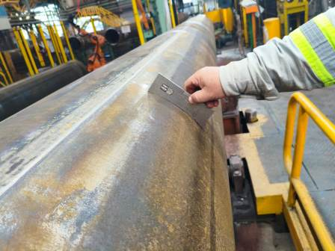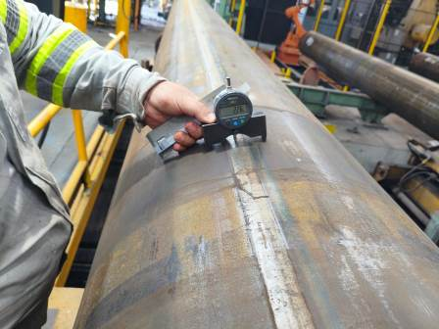

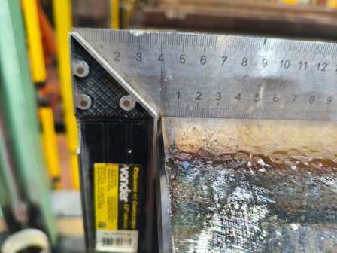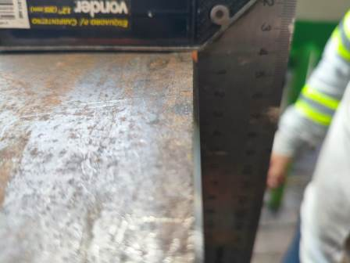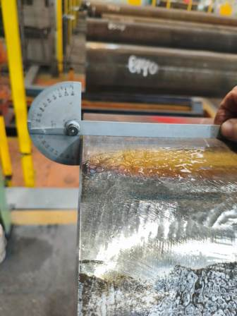
Pipe Mill Activities

End of this Report

